***ShopNest Capstone Report***

1. **Top Categories by Total Price**

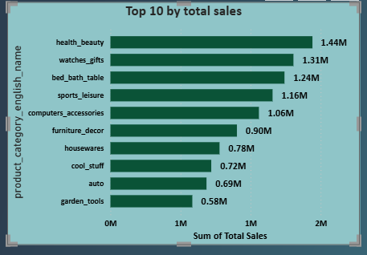

* + **Visualization Summary:**

The horizontal bar chart displays the top 10 product categories based on total sales in descending order. The x-axis represents the Sum of Total Sales (in millions), and the y-axis lists the product categories.

* + **Key Insights:**

1. Health_beauty is the top-selling category, surpassing 1.44 million in total sales. This suggests a strong consumer preference or demand for wellness and personal care products.
2. Categories like watches_gifts, bed_bath_table, and sports_leisure also perform exceptionally well, crossing the 1 million mark, indicating these are highly sought-after and possibly gift-oriented or lifestyle-enhancing.
3. computers_accessories and furniture_decor signal steady demand in both tech and home improvement sectors.
4. Lower on the list but still in the top 10, auto and garden_tools show niche but significant contributions to overall sales, suggesting potential for further exploration or seasonal promotions.
5. **Delayed Order Analysis**

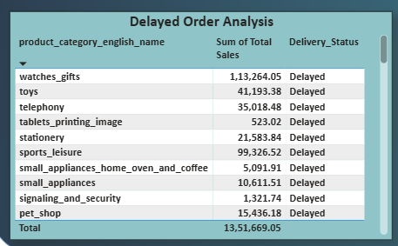

* + **Visualization Summary:**

This table provides insights into the total sales amount of **delayed orders** segmented by product category. Every listed order has the **Delivery_Status** marked as "Delayed"

* + **Key insights:**

1. **High-impact Categories:**

* **watches_gifts** alone contributes to over ₹1.13 lakh in delayed orders, indicating serious fulfillment issues in a high-demand, high-value segment.
* **sports_leisure** and **toys** also show significant delays, potentially leading to customer dissatisfaction in time-sensitive gifting or recreational purchases.

1. **Consistent Delay Across Segments:**

* **Delays are seen not just in tech or lifestyle products, but also in home appliances, pet supplies, and even stationery, suggesting a broader supply chain or logistics bottleneck.**

1. **Low-value Categories:**

* **Tablets_printing_image** and **signaling_and_security** have minimal delay amounts, but recurring issues in such categories can still affect brand reputation or specific customer experiences.

1. **Monthly comparison of delayed and on time orders**

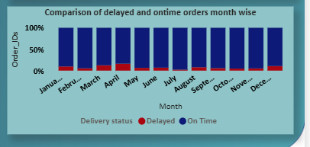

* + **Visualization Summary:**

A) **Type of Chart:** 100% Stacked Column Chart

B) **X-Axis (Month):** January to December

C) **Y-Axis (Order_IDs):** Representing the **percentage share** of delayed (red) vs on-time (blue) deliveries per month

D) **Legend:** 🔵 **On Time**, 🔴 **Delayed**

* + **Key insights:**
    1. **High Overall Delivery Performance:**
* Across all months, on-time orders (blue) dominate, consistently exceeding ~90% of total orders.

b) **Delay Consistency:**

* A small but visible proportion of delays (red) persists each month, suggesting that while most deliveries are on time, there is a recurring issue in a minor fraction of orders.

c) **Slight Monthly Variation:**

* March, April, and December show a slightly higher share of delayed orders compared to other months.
* This could correlate with peak shopping periods, promotions, or supply chain stress points.
  1. **Payment method analysis**

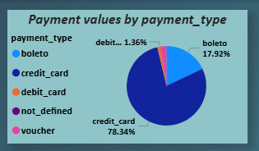

* + **Visualization Summary:**

A) Chart Type: Pie Chart

B) Measure: Payment values (%) by payment_type

C) Legend Categories:

* credit_card – Dark Blue
* boleto – Light Blue
* debit_card – Red-Orange
* not_defined – Dark purple
* voucher – Light Purple

| **Payment Type** | **Share (%)** | **Interpretation** |
| --- | --- | --- |
| Credit Card | 78.34% | Dominant method – customers heavily rely on credit card |
| Boleto | 17.92% | Second-most used – popular for users without cards |
| Debit Card | 1.36% | Rarely used, may indicate lack of integration or user preference |
| Voucher / Not Defined | 2.37% | Minimal impact, possibly deprecated or legacy data |

* + **Key insights:**

1. **Credit Cards Are King:** Over three-quarters of all payment value is processed through credit cards, highlighting this as the preferred and possibly most convenient option for most users.
2. **Significant Boleto Usage:** Boleto, a specific payment method, accounts for nearly 18%, showing a sizable segment prefers or requires non-card-based options.
3. **Low Debit and Voucher Use:** These methods represent a very small portion, which may be due to limited support or availability and business model focuses on post-paid transactions.
   1. **Product Rating Analysis**

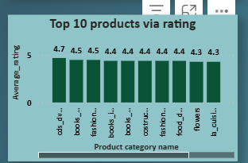 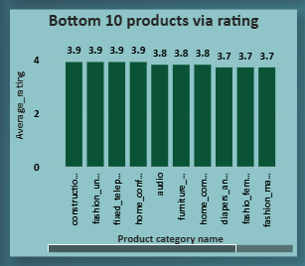

* + **Visualization Summary:**

A) Two bar charts:

1. **Top 10 Products via Rating and**
2. **Bottom 10 Products via Rating**

B) **X-axis:** Product Category Name

C) **Y-axis:** Average Customer Rating (Scale: 1 to 5)

* + **Key insights: Top 10 categories**
* **Media & Books Dominate**: Categories like cds_dvds_musicals, books_general, and books_imported consistently receive high ratings, indicating customer satisfaction with tangible, content-based products.
* **Gifting and Lifestyle**: flowers and costume_jewelry also rank high, reflecting appreciation in gifting or accessory segments.
* **Kitchenware & Decor**: la_cuisine and construction tools round out the top 10, showing utility-based items also perform well when quality is ensured.
  + **Key insights: Bottom 10 categories**
* **Comfort & Electronics Struggle:** Categories such as home_comfort, audio, and furniture_mattress receive lower ratings — these might suffer from quality, compatibility, or shipping damage issues.
* **Fashion (Men's & Underwear):** Low-rated fashion segments could reflect sizing issues, material dissatisfaction, or unmet expectations.
* **Safety & Utility:** Construction_tools_safety also performs poorly, potentially due to durability or compliance issues.
  1. **State wise Analysis**

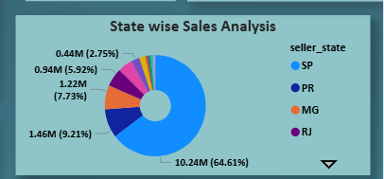

* + **Visualization Summary:**
* **Type:** Donut Pie Chart
* **Metric:** Total Sales (in Millions)
* **Breakdown by:** Seller_State
  + **Key insights: Top 10 categories**

a) **Highly Centralized Sales Distribution:**

* A single state contributes over 60% of the total sales, indicating a strong regional concentration of sellers and/or buyers.
* This dominance creates dependency risk on one geographic zone for revenue flow.

b) **Mid-tier Regional Support:**

* A few other states contribute between 7% to 9% each, acting as important secondary markets.
* These regions present good opportunities for scalable growth and diversification.

c) **Underutilized Markets:**

* Several states contribute less than 3% each, signaling potential for market development, seller onboarding, or customer acquisition strategies.
* These regions are low-risk testing grounds for new marketing tactics or pilot operations.
  1. **Seasonal Sales Pattern (Yearly and Quarterly as well)**

**2016**

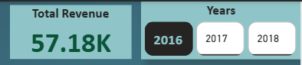 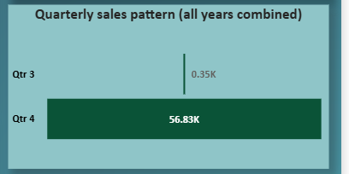

* + **Visualization Summary:**

| **Quarter** | **Sales (K)** | **% of Total Revenue** |  |
| --- | --- | --- | --- |
| Q3 | 0.35K | 0.61% |  |
| Q4 | 56.83K | 99.39% |  |

* + **Key insights:**
  1. **Q4 Dominance**:
* Nearly all revenue (99.39%) was generated in Quarter 4.
* This indicates a highly seasonal business model, with the bulk of activity in the last quarter.
  1. **Negligible Q3 Contribution**:
* Only 0.35K in Q3, accounting for just 0.61% of annual revenue.
* Suggests limited operations, demand, or product readiness during this period.
  1. **Seasonal Sales Pattern (Yearly and Quarterly as well)**

**2017**

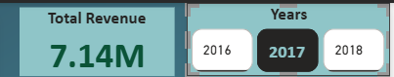 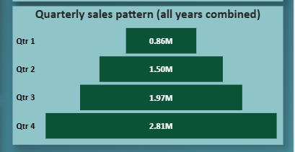

* + **Visualization Summary:**

| **Quarter** | **Sales (M)** | **% of Total Revenue** |  |
| --- | --- | --- | --- |
| Q1 | 0.86M | 12.04% |  |
| Q2 | 1.50M | 21.01% |  |
| Q3 | 1.97M | 27.60% |  |
| Q4 | 2.81M | 39.35% |  |

* + **Key insights:** 
    1. **Strong Year-Round Sales Distribution**
* All four quarters contributed **meaningfully** to revenue, showing a **steady and balanced growth trend** across the year.

2) **Q4 Remains the Peak**

* **Q4 generated 2.81M,** the highest among all quarters (≈39.37% of total revenue).
* While Q4 is still dominant, its share is less extreme compared to 2016 (which was over 99%).

3. **Growth Momentum from Q1 to Q4**

* Sales increased **consistently from Q1 (0.86M) to Q4 (2.81M)**, indicating possible:
  + Seasonal market trends,
  + Progressive product rollout or marketing impact,
  + Stronger customer adoption later in the year.
  1. **Seasonal Sales Pattern (Yearly and Quarterly as well)**

**2018**

 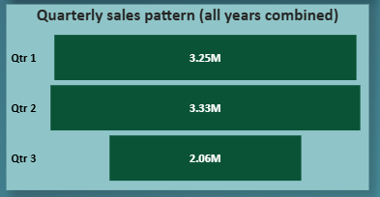

* + **Visualization Summary:**

| **Quarter** | **Sales (M)** | **% of Total Revenue** |  |
| --- | --- | --- | --- |
| Q1 | 3.25M | 37.61% |  |
| Q2 | 3.33M | 38.54% |  |
| Q3 | 2.06M | 23.85% |  |

* + **Key insights:**
  1. **Q1 and Q2 Dominate Sales**
* **Q1 (3.25M)** and **Q2 (3.33M)** combined account for **over 76%** of the annual revenue.
* This is a major shift from 2017 where **Q4 led sales** —now **early-year performance is stronger.**

2) **Q3 Decline**

* **Q3 contributes only 2.06M (23.85%),** indicating a drop in sales momentum. Due to the following reasons:
  + Mid-year seasonality,
  + Reduced demand or campaign activity,
  + Shift in buyer behavior or internal capacity issues.

3) **Overall Growth Trend**

* Despite missing Q4, 2018 shows **higher total revenue (8.64M)** than 2017 (7.14M), indicating **strong business growth** year-over-year.

**The end of report**